The church at Clifton Campville: lordship and community

12th and early 13th centuries
Clifton is first mentioned in the year 941 and first appears with the suffix ‘Campville’ in 1194. The suffix comes from the Camville family, which appears to have been Norman, possibly originally from Canville-la-Rocque in Manche in west Normandy, or alternatively from Canville-les-deux-Eglises, also in Normandy. The family may have come to England with William the Conqueror in 1066; certainly, some Camvilles were prominent in 12th-century England. The earliest record of a Camville associated with Clifton, however, is William Camville, who is recorded as holding land in Clifton Campville in 1200. Perhaps significantly, the earliest surviving parts of St Andrew’s parish church in Clifton date from the same time.

During the reign of King John in the early years of the 13th century, England was involved in a war against France which culminated in the loss of Normandy to France in 1204. This led to Norman lords, if they had held land on both sides of the Channel since 1066, being compelled to decide between Normandy and England. Some decided that now was the time to invest in their English holdings and amongst these were the Camvilles, who had acquired extensive estates in England during the 12th century, particularly in Somerset and the Midlands, but also in Wales and Ireland. Perhaps they still held land in Normandy but, as they had been well connected with the English royal court during the reigns of Stephen, Henry II, Richard I, and John, it may have seemed sensible to them to focus on consolidating their position in England as soon as they foresaw the likely consequence of John’s war over Normandy.
Figure 1:
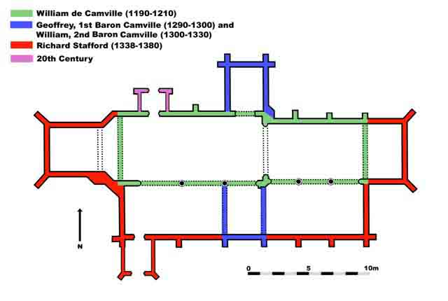
The development of St. Andrew’s Church, Clifton Campville, 1190 to 1380

© B Cunliffe

It certainly appears that William Camville, who was lord of Clifton Campville from before 1200 to some time after 1210, aimed to establish himself in England by investing in his English estates. As part of this strategy, it is likely that he settled in Clifton and paid for the building, or re-building, of the church. Domesday Book records that there was a priest at Clifton in 1086, which should mean that there was a church, although there is no architectural evidence for it in the present fabric. William Camville’s church was a relatively simple building consisting of a nave and a chancel. [see Fig. 1] Surviving parts of this building can be seen in the remains of lancet windows in the north wall of the chancel and in the stonework of the north wall of the nave. [see Fig. 2] Further consolidation of the Camvilles’ position can be seen in Clifton with the appending of the family name to that of the village from 1194 onwards. It is unclear whether this would have been done by the family themselves or by Crown officials but, either way, it shows a clear link between the family and the place. It is reasonable to suppose, therefore, that William Camville knew, and could well have been resident in,
the village.
Figure 2:
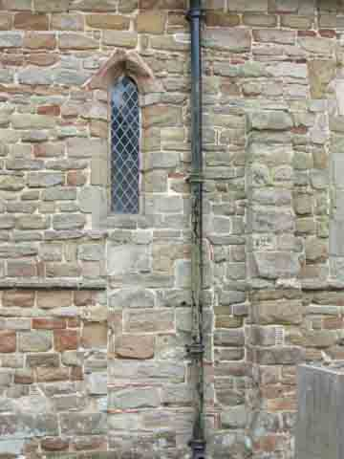
Remnants of William de Camville’s church – late 12th/early 13th centuries

These views of the exterior north wall of the chancel show Early English lancet windows. They survive from the late 12th/early 13th century building constructed during the lordship of William de Camville, who was lord of the manor from before 1200 until after 1210.

In the lower picture, the lancet window has been blocked at a later date, perhaps when the newer window seen in the picture was inserted in the 15th century.

Photo © I M Curr

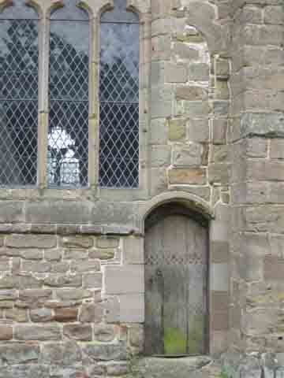

Photo © I M Curr

Late 13th and early 14th centuries
The Camville family continued to be lords of Clifton throughout the 13th and early 14th centuries, although investment in the manor seems to have been interrupted during the 1240s when there was a dispute over the ownership of the manor between two of William’s grandsons, who were half brothers. Their widows pursued the legal case in vain when Geoffrey Camville, probably William’s great-grandson, became lord of the manor in 1260. In the 1290s Geoffrey was created 1st Baron Camville. His status as a baron put him in a position where he would be expected to invest in his lordship and so it is not surprising that his period as lord corresponds with a significant phase of building in the church: a cruciform building was created by adding two transverse chapels to William’s simple two-cell building of a hundred years before. [see Fig. 1] It is worth noting that, during Geoffrey’s time as lord of Clifton (1260 to c.1308), the rector of the church (from 1299 to 1323) was Jordan de Camville, who may well have been a relative of Geoffrey, thus forging particularly close links between the manor and the church.

The north transverse chapel
The north chapel which was built by Geoffrey still survives in almost its original form: the chapel on the ground floor and living quarters above. [see Fig. 3] It is possible that it was designed as a chantry chapel with accommodation for a chantry priest, but there is no documentary evidence to corroborate this. A detailed survey of this chapel was made in the 1990s. [Although sometimes called a ‘transept’, the correct terminology is ‘transverse chapel’ as a transept refers to parts of a church under a central tower, which does not exist at Clifton.]
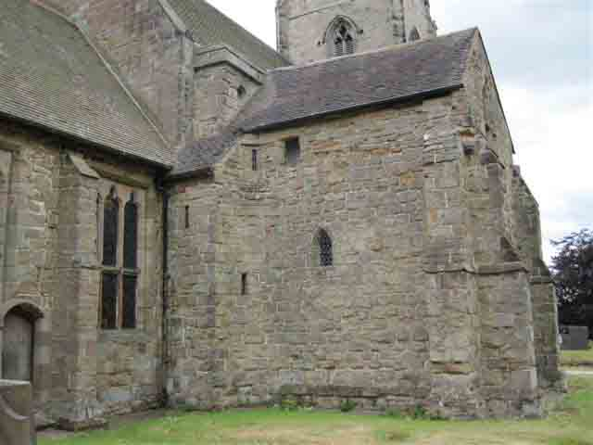
Figure 3:
North transverse chapel built in the time of Geoffrey, 1st Baron Camville -
late 13th century

East elevation. The high level ground floor window is so positioned because it is above an internal altar. The first floor window (with wooden shutters) to the upper chamber can be seen, as can the turret (in the angle between the chapel and the chancel) containing the spiral staircase which leads to the upper floor.

Photo © I M Curr

The south transverse chapel
The south chapel is now incorporated into the later south aisle, [see Fig. 4] and, like the north chapel, was an important addition to the church. On the south wall of what was the south chapel there is a low arch enclosing a recess which contains a wall painting. The position of the painting, in the upper section of the recess, could suggest that there was originally a tombstone or effigy in the lower section. There is a low platform, within the arch, which could well have supported a tomb slab.
Figure 4:
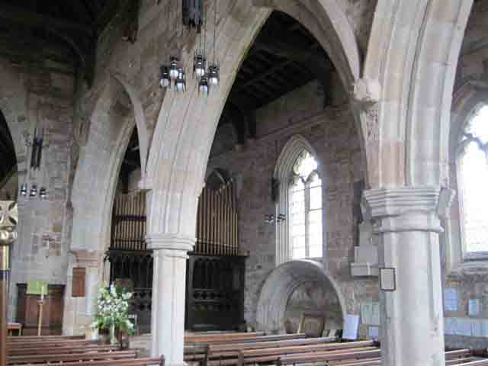
South transverse chapel built in the time of Geoffrey, 1st Baron Camville
– late 13th century
This view is from the nave looking south-east through the arcade between the nave and the south aisle. The arch under the window on what was the south wall of the south chapel can be seen. The recess under the arch contains a wall painting above – probably – a tomb. To the right of the picture is the south aisle, also known as the Haunton aisle.

Photo © I M Curr
The arch has been dated to c.1300. According to the church guidebook, Stebbing Shaw suggested that the arch marks the tomb of Richard Stafford (died 1381), but what Shaw actually says is that the arch had a painted inscription (no longer visible by his time, having been whitewashed): ‘Here lyeth the founder of this church’. Shaw does not specify who might have been so described. It seems unlikely that an arch constructed in 1300 would house the tomb of someone who died eighty years later. In any case, by the time Richard died, the new chantry chapel (known today as the Lady Chapel) had been built. That chapel would have been a more fitting resting place for such an important individual as Richard Stafford, particularly as he probably helped to finance the building of the Lady Chapel.

E. W. Tristram, who examined the arch and the wall painting in the 1930s, proposed that the arch might contain the tomb of Richard Vernon (died 1338). Vernon was married to Maud (also known as Matilda, the Latin form of the name), Geoffrey Camville’s grand-daughter, and Tristram suggested that she was buried on the opposite side of the church
in the still extant tomb on the north wall of the nave. [see Fig. 5]
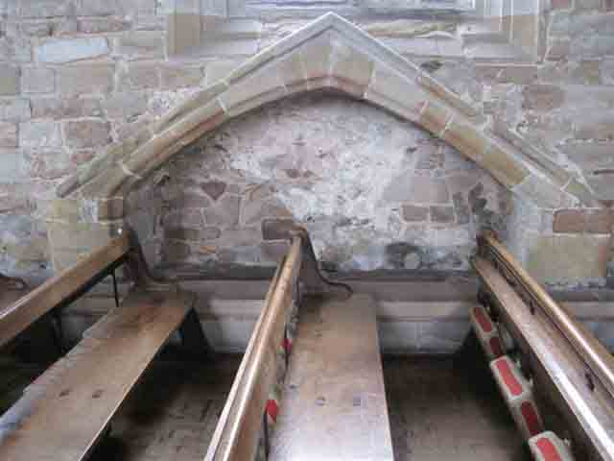

Figures 5a–b:
Tomb on the north wall of the nave
This tomb was described by Stebbing Shaw in 1798 as having borne the inscription: Here lyeth the founder’s wife. The upper picture shows the tomb recess and the lower picture is of the tomb slab within it. Further research on the date of this feature would be helpful in determining whose tomb this might be.

Photo © I M Curr
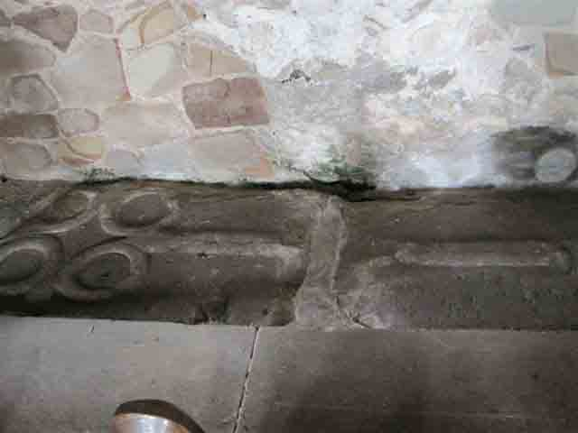

Photo © I M Curr

According to Shaw, this tomb in the nave had carried the inscription, ‘Here lyeth the founder’s wife’, linking it with the tomb in the south transverse chapel. It seems unlikely, however, that Richard Vernon could be described as having founded the church, and it also seems improbable that his wife would be buried in a separate tomb from her husband and in a completely different part of the church.

Further research on the tomb in the nave would be useful to establish its date. If it were dated to the late 13th century, it could be the tomb of Maud, first wife of Geoffrey, the first Baron Camville. Maud seems to have died in the 1270s, before the transverse chapels were built. This would make it possible that the arch in the south chapel marks the tomb of Geoffrey. He outlived Maud by over thirty years, during which time the chapels were probably constructed thus providing an appropriate place for his tomb. Geoffrey died sometime before or during 1308. He could well have been described as ‘the founder of this church’ in view of the extensive additions – the two transverse chapels – made to the church during his time as lord of Clifton. So the tomb in the south chapel could date from circa 1308 and have been placed in a chapel recently built to house it.

The wall painting above the south chapel tomb has been dated to the early 14th century, so it is possible that the arch and the painting are contemporary with each other, perhaps both in honour of Geoffrey. Another possibility for the origin of the painting is that it is slightly later than the arch and tomb, dating from the time of William de Camville, the second baron. He was lord by 1308 and died after 1332, apparently with no male heirs. As mentioned above, his daughter Maud married Richard Vernon of Haddon and Harlaston. The date of their marriage is uncertain but was probably around 1310. By 1322 William had given 260 acres of land in Clifton Campville to Maud and to Richard, who died in 1323. Whether this Richard was Maud’s husband or her son is not entirely clear: an Inquisition Post Mortem of 1323 is ambiguous, but the fact that Maud appears on the Subsidy Rolls of 1327 and 1332, and Richard does not, suggests that she was a widow by 1327. In return for the land, Maud and Richard were to give William a pair of gilt spurs every year.
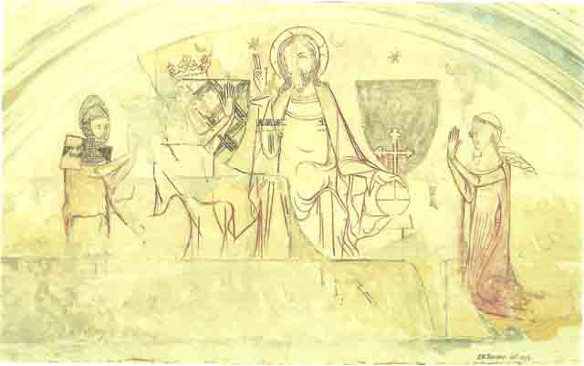
Figure 6:
Wall painting on south wall of south transverse chapel,
from the time of William Camville – c.1308 to c. 1338

This reconstruction by Tristram, who uncovered and studied the wall painting in the 1930s, shows the picture in greater clarity than can be seen in the actual painting today.

The picture shows the coronation of the Virgin, the stars indicating that it took place in heaven. The figure of Christ is in the centre, with his left hand on an orb and his right hand raised in blessing. The crowned Virgin is seated, with her hands raised in prayer. Her face has been obscured by the later addition of an armorial shield showing the arms of the Vernon family. It seems likely that this would have been added after the Reformation, when the Virgin was no longer to be venerated. Tristram has shown the Virgin’s hands and the cross on top of the orb but in fact these features were not visible after the heraldic shields had been painted on top of the original picture.

The kneeling figure on the right of the picture could well be Maud and the corresponding figure on the left could be her husband, Richard Vernon. It was customary for the donors of a picture to be portrayed in this manner.

The wall painting [see Fig. 6] shows the coronation of the Virgin, with Christ in the centre and the crowned Virgin at his right hand. The figures kneeling on each side are presumably the donors. The woman could well be Maud: she is shown wearing a typical head-dress of the early 14th century. The other figure could be Maud’s husband, Richard Vernon. He is depicted as a knight wearing armorial ailettes on his shoulders. (Ailettes were part of a knight’s attire usually dated to between c.1275 and c.1350.) A study of the painting in 1961 suggested that the ailettes are painted with the fretty pattern of the Vernon arms [see Fig. 7]. This figure is unlikely to be Maud’s son as, if he was the Richard who died in 1323, he appears to have died before he was twenty so would probably not have attained the status of a knight. It therefore seems plausible that the painting could have been commissioned by Maud and her husband, Richard Vernon the elder, perhaps following the death of their son, the young Richard, in 1323. If the Richard who died in 1323, however, was Maud’s husband, then perhaps Maud commissioned it in his memory. Another possibility is that she commissioned it after her father, William, died in 1337/38, in gratitude for her inheritance: the manor stayed in the Camville family, albeit through the female line. The two shields [see Fig. 7] which were added later to the painting (see section on The 16th century, below) show the Vernon arms on the left and, possibly, the Camville arms on the right. As one of them is painted on top of the Virgin’s face, it seems probable that these were not added until after the Reformation.
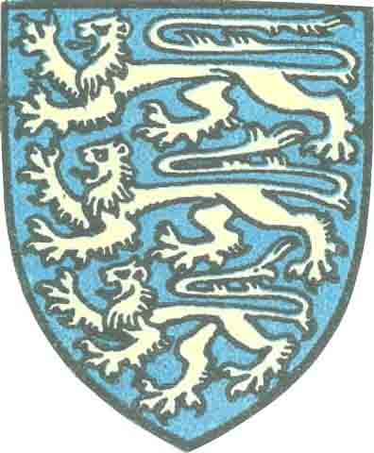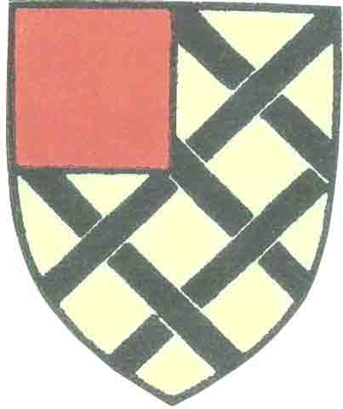
Figures 7a–b:
Heraldic shields, as seen on the wall painting

- The shield of the Camville family. It is possible that this is the shield which is shown on the wall painting, between Christ and the kneeling woman who is possibly Maud Camville.
- The shield of the Vernon family. This can be seen on Tristram’s reconstruction, painted over the face of the Virgin
The later 14th century
At some later stage in the 14th century, further considerable additions were made to the church: the tower and spire were built, the chancel was extended, an aisle was added to the south side of the nave, and a chapel was constructed adjoining the south side of the chancel. [see Fig. 1]

There is some disagreement about the timing and sequence of these additions. Some writers attribute them to the first half of the 14th century, a time of mixed fortunes for the Camville family. On the one hand, William, who was lord of the manor from before 1308 until the late 1330s, was 2nd Baron Camville and thus clearly of some status. On the other hand, the succession of the family estate must have seemed uncertain after the death in 1323 of Richard Vernon (either William’s son-in-law or his grandson), leaving William with no male heirs. This situation might have encouraged William to invest further in the manor in order to strengthen the family’s position.

It is therefore possible that the 2nd Baron, William, was responsible for additions to the church, continuing what the 1st Baron had begun. However, recent research attributes the new building to the second half of the 14th century, specifically to the period c.1353 to the 1370s. This period seems to have marked a peak in Clifton Campville’s manorial status, despite the male Camville line having died out when William, the 2nd Baron, died, apparently in about 1337/8. What happened next is unclear, as it depends on whether the Richard who died in 1323 (see above) was Maud’s son or her husband. If Maud was still married, she would have unable to inherit the manor in her own right and the manor would have passed to her husband. If she was a widow, she could possibly have inherited the land herself. Whatever happened immediately after William’s death, it seems that by 1338 the manor had passed to his son-in-law, Richard Stafford.

Richard Stafford was descended from a cadet line of the powerful Stafford family. As a junior member of the Stafford family he was perhaps anxious to make a name for himself in some way. In his youth he had been outlawed but he seems to have redeemed himself though service with Edward III and with the Black Prince in the Hundred Years War during the 1340s and 1350s. His marriage to Isabella Vernon in about 1337 led to his becoming lord of Clifton. Although military service took him out of the country, particularly during the late 1350s and early 1360s, it seems likely that he maintained close links with Clifton through his wife and also through his association with Hugh de Hopwas.

Hugh de Hopwas was rector of Clifton for over thirty years. He had obtained his first benefice in 1346, through the patronage of Richard Stafford, and he was subsequently appointed to a total of seven benefices – some concurrently – before he was appointed to Clifton Campville in July 1353. He remained as rector in Clifton until his death in 1384, during which time he held a number of other benefices and was also a canon of Lichfield Cathedral.
It seems that the partnership of Richard Stafford and Hugh de Hopwas, both of whom probably lived in Clifton, could have made possible the extensive additions to the church at Clifton during the period 1353 to 1384.
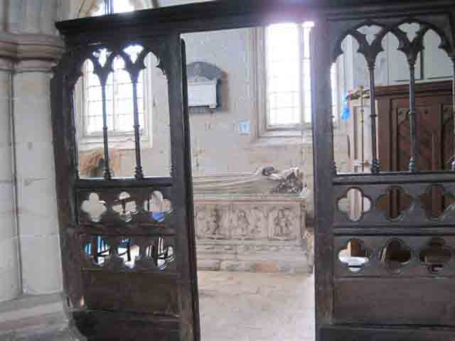
Figure 8:
The Lady Chapel of Hugh and Richard – after 1361
This is presumed to be the chantry chapel founded by Hugh de Hopwas in 1361. The chapel now houses the 1545 alabaster tomb of John Vernon of Harlaston and his wife, Ellen.

Photo © I M Curr

The chapel which is now known as the Lady Chapel seems to be associated with Hugh’s founding of a chantry in 1361. According to the deed which established the chantry, it was located ‘at the altar of the Virgin at the south side of the church’. This reference, along with a study dating the building styles and the screens, has led to Hugh’s chantry being identified as the present Lady Chapel. [see Fig. 8] Hugh employed a chaplain to say masses in the chantry for specified people including: Richard Stafford, Richard’s late wife Isabella Vernon, his current wife Maud and all their children, the Prince of Wales, the bishop of Coventry and Lichfield, Hugh himself, a couple who were probably his parents, his lawyer, all those who had died in any place where Hugh had connections, and a host of other people. The deed of establishment goes into minute detail about the duties of the chantry priest: it states the number of days absence he is allowed and says that, even when away from Clifton, he must still say the masses as stipulated. There is reference in the document to the muniments of the chantry being kept in a chest in the church. This might have been the chest which still survives in the church and which has been dated to the late 13th century. [see Fig. 9]
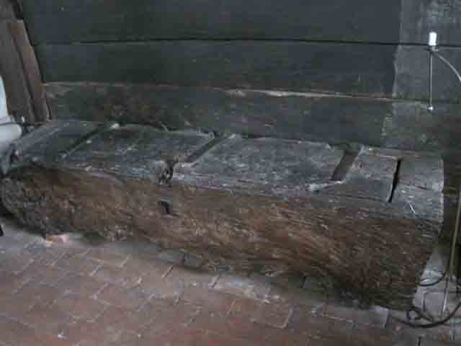
Figure 9:
Oak chest for storage of muniments – 13th century

It is possible that this chest, which dates from the late 13th century, is the chest referred to in the document which set up Hugh de Hopwas’s chantry. The document says: All muniments of the chantry are to be kept in a chest in the church with two locks, one key to be kept by the Rector and the other by the chaplain, and neither shall have any of the muniments in their possession without sanction of the other.

Photo © I M Curr

The establishment and apparent continued existence of the chantry suggests that there was money available to support the venture. There is evidence for Hugh de Hopwas appointing chantry chaplains on three occasions during the 1360s. A document of 1370 confirms a grant, made to Hugh, of land in Leicestershire, Warwickshire, and Staffordshire to pay for the chantry chaplain. Richard Stafford might also have contributed to the expenses of setting up and maintaining the chantry. It is possible that Hugh and Richard might have been hoping to establish a chantry college. Although there is no evidence of their having achieved this, the high quality carving on the 14th century stalls in the church has been suggested as evidence that the church was important enough to have several priests. The stalls correspond in style with this period of expansion at
Clifton and they seem to have been made to measure, to fit adjacent to the 14th century screen between the chancel and the Lady Chapel. Thus it seems reasonable to suppose that they were installed as part of this late 14th century building phase in the church. It is known that there were at least two priests (the rector and the chantry priest) in the late 1300s and by 1406 there were four. Hugh de Hopwas may well have continued to conduct services in the church whilst the other clergy ran the chantry.

The ambitions of Hugh de Hopwas and Richard Stafford did not stop at the foundation and construction of the chantry chapel. At about the same time, the nave was extended to the south by the addition of an aisle, sometimes known as the Haunton aisle. [see Fig. 4] This incorporated the south transverse chapel of Geoffrey Camville’s time, although the stonework on the interior wall could suggest that what had been the south chapel still remained separate for some time. [see Fig. 10]

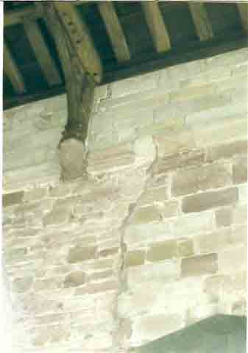
Figure 10:
Hugh and Richard’s church: south transverse chapel and south aisle, showing join in masonry – 1338 to 1380

The south chapel is to the left and the south aisle is to the right. The break in the string course could suggest that the west wall of the chapel still existed after the construction of the aisle, and that it was removed only when the roof level was raised at a later date. This would mean that the south chapel was initially preserved as a separate space when the south aisle was built.

Photo © I M Curr

The new south aisle included a new entrance to the church. [see Fig. 11] This leads from an area where a ridge and furrow pattern still survives on the site of Clifton’s open fields. Perhaps the church’s south porch was intended to provide an entrance for the villagers, separate from that used by the lord. As the church porch was often the scene of ceremonies such as weddings and a place for conducting church business, it is possible that Richard and Hugh wished either to separate themselves from such events or to make access more convenient for the villagers.
Figure 11:
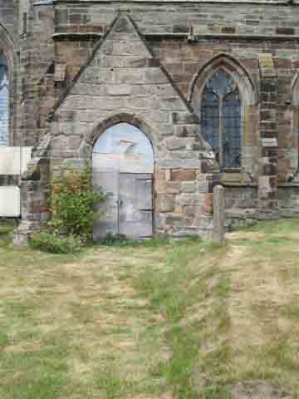
Hugh and Richard’s church: south porch – late 14th century

Note the well-worn pathway leading to the porch

Photo © I M Curr

The existence of possible burgage plots in the village could also suggest, depending on the date of their establishment, that Hugh and Richard were investing in the manor. If not in Hugh and Richard’s time, then the existence of burgage plots suggests that the Camvilles had been investing in the manor at an earlier date, perhaps as early as the 1190s when the manorial suffix was added.
Also constructed during the time of Hugh and Richard was the eastward extension of the chancel. The first church, built by William de Camville, had a two-bay chancel, which Hugh and Richard extended by one bay. The new east wall incorporated the window which still survives and which has been described as ‘one of the best windows in . . . Decorated style in the diocese’. [see Fig. 12] This is a significant addition to the church since the chancel was the holiest part of the building. The chancel extension with its dramatic window must have made a striking impression.
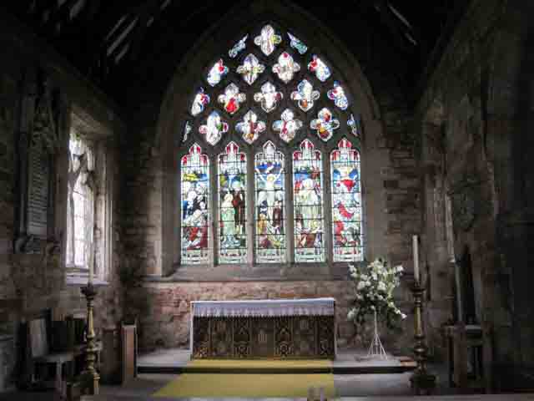
Figure 12:
Hugh and Richard’s church: east window of chancel in Decorated style
– late 14th century

The easternmost bay of the chancel, seen here, was added during the time of Hugh de Hopwas and Richard de Stafford, and the impressive east window was included in that phase of building.

The window on the side wall, to the left, is a later window inserted in the 15th century.

Photo © I M Curr

Finally, during this period, the tower and spire were built, probably after 1370. The spire is a dramatic feature of the church which is visible from miles around. [see Fig. 13] It can be seen from Lichfield, where Hugh was a leading member of the Cathedral Chapter and where he owned houses in the Close. The existence of a deer park could be a further sign of Hugh’s status, or perhaps of his aspiration. To the north-west of the village there is an area where eight out ten field names include the word ‘park’, for example, Lower Park, Upper Park, and Wilkins Park. The area is small for a manorial deer park, but its size and location are consistent with a clerical deer park. If not established by Hugh, then it would presumably have been set up by one of his predecessors.
Figure 13:
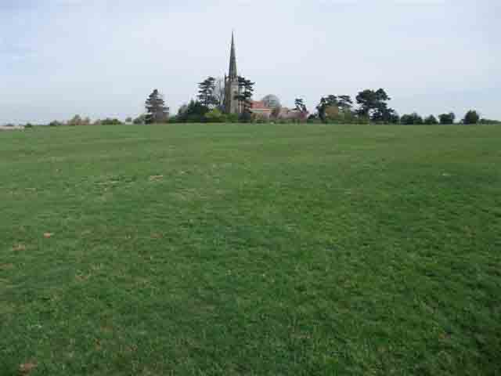
Hugh and Richard’s church: the spire – late 14th century
Photo © M Simpson

Various motives can be suggested for the additions which Hugh de Hopwas and Richard Stafford made to Clifton Church in the late 14th century. They were probably concerned for their souls, hence the chantry (for prayers) and the chancel extension (to gain some credit with the Almighty); they were perhaps concerned to impose their authority on, and to keep their distance from, the villagers, whilst still providing for the villagers’ religious needs, hence the south aisle and porch; and they perhaps wanted everyone to know what they were doing, hence the tower and spire. All this contributed to their over-riding desire which was to invest in the church and manor of Clifton.

Both Hugh and Richard spent time away from Clifton: Richard on military service and Hugh on church business, but they undoubtedly made an impression on Clifton Campville.

The possible site of Richard Stafford’s tomb in the south transverse chapel has already been discussed. It certainly seems credible that he was buried in the church, since he had supported so much development there. The new chantry chapel would have made the most appropriate location for Richard’s burial in 1381, although there appears to be no surviving evidence of his tomb. It has been suggested that the tomb in the north wall of the nave is that of Richard’s first wife, Isabella Vernon (died 1356). However, this is based on Stebbing Shaw’s description of that tomb having had a painted inscription, ‘Here lyeth the founder’s wife’, corresponding to the inscription over the tomb in the south transept. If the latter is not, after all, Richard Stafford’s tomb, then it is unlikely that the tomb in the north wall is Isabella’s. It has also been suggested that the brass in the Lady Chapel might be a memorial to Richard’s second wife, Maud, who may have died in about 1360, but there is no clear evidence to support this.

Richard Stafford’s eldest son, yet another Richard, predeceased his father, so Richard Stafford was succeeded by his second son, Edmund. Edmund was a powerful man: a priest whose clerical posts included dean of York and bishop of Exeter. When Hugh de Hopwas died in 1384, Edmund became rector of Clifton, so that the lord of the manor and the rector were united in one person. It is possible that the old rectory house in Clifton was also (or now became) the manor house and that from this moment Clifton became a Rectory Manor due to Edmund Stafford being both lord and rector. The rectory house, now known as the Old Rectory, has a 15th-century core but could be on the site of an older building. [see Fig. 14]
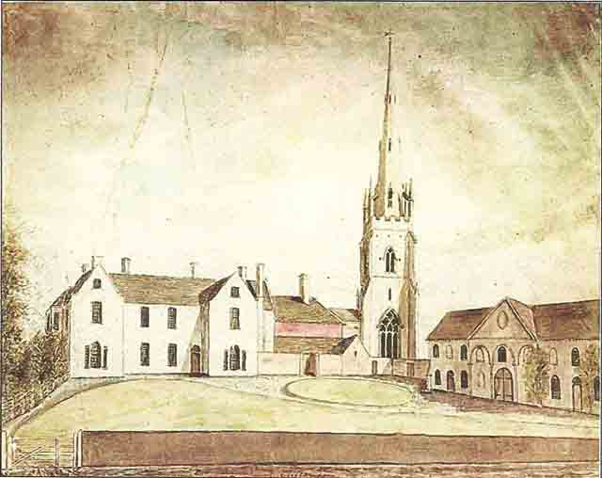
Figure 14:
The Rectory House in 1790

This watercolour drawing is by Stebbing Shaw and dates from c. 1790. It shows (on the left) the rectory house, which has a 15th century core, as it appeared after alterations in 1778. The buildings to the right are stables.

Reproduced by kind permission of Trustees of the William Salt Library

Edmund Stafford went on to hold great offices of state during the reign of Richard II, including Keeper of the Privy Seal (1389 – 1396) and Lord Chancellor (1396 – 1399), so it is unlikely that he spent much time at Clifton. Richard II allegedly stayed at Clifton Campville from 8 to 11 February 1398 and it is possible that he was also staying there in August 1390. The unusual situation of the king gracing such a small village with his presence can be explained by Edmund being both lord of the manor of Clifton and Lord Chancellor at the time. However, this is based upon the issuing of documents at Clifton and since, at this time, documents could be issued in the king’s name by the Lord Chancellor without the King being present, it is not certain that the king did actually visit Clifton.

The 15th century
By about 1400, then, the basic structure of the church was much as it is today. After Edmund Stafford’s death in 1419, the lordship passed to his nephew Thomas and then down the Stafford line. It is likely that the lords had ceased to be resident by this time and so had no reason to invest either in the church building or in the village.

It also appears that the rectors were not resident after Edmund Stafford’s time, as the four rectors who succeeded Edmund Stafford all held significant posts elsewhere, including John Stafford who was archbishop of Canterbury. Further evidence that the rectors were non-resident comes in 1453 when the new rector in that year, Robert Godibowre, registered a complaint that the rectory house was in a serious state of disrepair. An official survey was conducted and the estate of the late rector, William Duffield, was charged with making the necessary repairs at a cost of £133 6s 8d. If the rectory was also the manor house, then the dilapidated state of the building epitomises the decline of the manor by the mid 15th century.

At some stage during the 15th century, new windows were inserted in the church chancel. [see Fig. 15] It would be interesting to have more precise dating for these windows. Perhaps Robert Godibowre, dismayed at the state of the rectory house, decided to make an impression on the church. Perhaps Godibowre also rebuilt the rectory house: the oldest parts of the present building date from the 15th century. It seems unlikely that the lords of the manor, now absentee lords, would have taken any initiative in the church or the manor at this time.
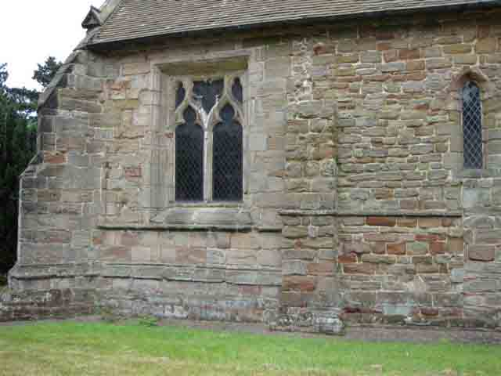
Figure 15:
Exterior view of chancel

The extension to the chancel, built in the time of Richard Stafford and Hugh de Hopwas, can be identified by the change in stonework. The window in the extension is a later 15th century insertion.

Photo © I M Curr

The 16th century
In the 16th century, the lords were probably still absentees and the main addition to the church came from a family which did not have a direct link with Clifton. This was the Vernon tomb of 1545 [see Fig. 16], which is now in the Lady Chapel. John Vernon was lord of Harlaston rather than of Clifton but perhaps wanted the status of being buried in a large and impressive church. There is a suggestion that this tomb was moved to its present location sometime before 1634 from a position closer to the chancel. This may reflect the religious upheaval of the 16th and 17th centuries. The Lady Chapel, having been originally built as a chantry chapel, would have lost that function after Edward VI’s dissolution of the chantries in 1547. This might have given the opportunity to place the tomb into its more prominent position in the chapel, although it was not until 1634 that the screen was erected in what is supposed to have been the tomb’s previous position between the chapel and the chancel. It is possible that the heraldic shields, superimposed on the wall painting in the south transverse chapel, were painted at about the same time as the Vernon tomb was installed. These shields were presumably added after the Reformation since one of them obliterates the Virgin’s face, so the 1540s would be the earliest date at which they could have been painted. One of the shields shows the arms of the Vernon family and the addition of these shields to this much older tomb and painting perhaps suggests that the Vernons wanted to gain some status by associating themselves with Clifton Campville and with its ancient history.
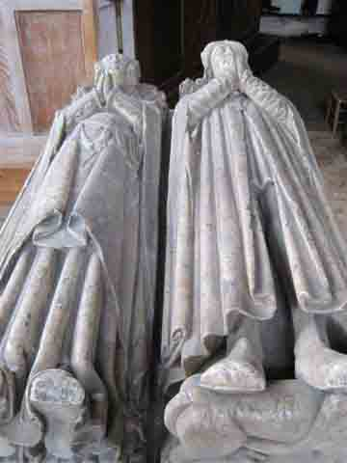
Figure 16:
Tomb of Sir John Vernon of Harlaston and of his wife, Ellen – 1545

This tomb, dating from 1545, is in the Lady Chapel. There is some evidence that it might have been moved to its present position from a site nearer to the chancel.

Sir John Vernon had no specific connection with Clifton but he may have hoped to gain status by having a tomb in Clifton church and thus making a link with his ancestor who had married a Camville two hundred years earlier. It may also have been Sir John who, for the same reason, had the Camville and Vernon shields superimposed onto the south chapel wall painting.

Photo © I M Curr

The manor of Clifton Campville, and its church, benefited from investment by its lords during the twelfth and thirteenth centuries and from the partnership between lord and rector in the fourteenth. During the rest of the medieval period, absentee lords and non-resident rectors seem to have shown little interest in the development of the village. This lack of interest has contributed to the survival of the many medieval features in the church and its surroundings.

Endnotes

Abbreviations
HER Historic Environment Record (Staffordshire County Council)
SHC Staffordshire Historical Collections (Staffordshire Record Society)
VCH Victoria County History

D. Horovitz, The Place-Names of Staffordshire (2006), referring to document dated 1194 in SHC III (i) (1882), 25.
G. E. Cockayne, revised V. Gibbs and A. Doubleday, The Complete Peerage (1913).
B. Golding, ‘Gerard de Canville (d. 1214)’, Oxford Dictionary of National Biography (2004); online edition October 2006 http://www.oxforddnb.com/view/article/4543 (viewed 18 February 2011)
The Battle Abbey Roll www.1066.co.nz/library/battle_abbey_roll1/ (viewed October 2010)
Richard de Camville, apparently the father of William Camville (see below), was a king’s justice who died in Italy in 1176 whilst escorting Henry II’s daughter to her Sicilian marriage: D. M. Stenton, English Justice between the Norman Conquest and the Great Charter (1965). Richard’s eldest son (i.e. William’s elder brother), also called Richard, was governor of Cyprus and took part in the Third Crusade. Another son, Gerald, was castellan of Lincoln castle and a supporter of King John against Richard I. (B. Burke, Extinct Peerage and Baronetage (1840), 106).
SHC II (1881), 97 [Staffordshire Pipe Rolls: reference to the Auxilium Vicecomitis (a tax on land) in which William de Camville is recorded as holding 8 hides in Clifton Camville in 1200].
R. A. Meeson, The Chantry Priest’s Room, St. Andrew’s Church, Clifton Campville – An archaeological watching brief (1997).
A. L. Poole, From Domesday Book to Magna Carta (1955), 432.
VCH Oxfordshire VI (1959), 243–51 (Middleton Stoney); online edition http://www.british-history.ac.uk/report.aspx?compid=63743 (accessed 22 March 2011); VCH Somerset VII (1999), 84–93 (Charlton Horethorne); online edition http://www.british-history.ac.uk/report.aspx?compid=18740 (accessed 23 March 2011); VCH Warwickshire (1945), 26–31 (Arrow); online edition http://www.british-history.ac.uk/report.aspx?compid=56976 (accessed 23 March 2011).
D. M. Stenton, English Justice between the Norman Conquest and the Great Charter (1965); Burke, Extinct Peerage and Baronetage, 106.
J. Morris (ed.), Domesday Book: Staffordshire (Chichester: Phillimore, 1976)
Meeson, Chantry Priest’s Room.
SHC IV (part 1) (1883), 99–100 and 144–149 [Plea Rolls].
Burke, Extinct Peerage and Baronetage, 106 et seq.
Meeson, Chantry Priest’s Room.
Meeson, Chantry Priest’s Room.
J. Granvill and J. Burbidge, St Andrew’s Church, Clifton Campville, Staffordshire: Report on Phase 1 of the Investigation and Conservation of the Wall Paintings (1998).
HER, PRN Number 09499-MST5208 (St Andrew’s Church Clifton Campville, Listed Building no.: 1893/11/002).
M. Browne, Guidebook to St Andrew’s Church, Clifton Campville (1998).
S. Shaw, History and Antiquities of Staffordshire (1798).
E. W. Tristram, English Wall Paintings of the Fourteenth Century (1955), cited in Granvill and Burbidge, St Andrew’s Church.
SHC 1911, 300 [Inquisitions Post Mortem; ipm of 21 September 1308, referring to Geoffrey de Camville as having died].
HER, PRN Number 09499-MST5208; Granvill and Burbidge, St Andrew’s Church.
William, the 2nd Baron, was either son or grandson of Geoffrey (who had died by 1308, see above); the last mention of William living is in 1332: SHC X (1889), 104 [Subsidy Roll 1332/3].
? The date of the marriage can be deduced from when their children were born. Richard de Vernon had a son called William, who is believed to have been born before or during 1313: SHC 1911, 355 [Inquisitions Post Mortem; ipm of 3 Feb 1323]. The same document mentions William being ten years of age at that time. This IPM was occasioned by the death of ‘Richard, son of Richard de Vernon and Maud’. The IPM says that ‘William son of Richard de Vernon is his next heir’. This would suggest that the Richard who had died was older than William, which – if he was Maud Camville’s son - would mean he was probably born before or during 1312 which, in turn, implies that Richard de Vernon and Maud Camville were married before or during 1311. An article on the internet states that they married in 1309 or earlier, but no sources are cited to support this statement: newsgroups.derkeilor.com (viewed October 2010).
SHC 1911, 355 [Inquisitions Post Mortem; writ of diem clausit extremum, 3 Feb 1323, on the death of Richard de Vernon’s son (also called Richard), referring to William having given land to Maud and ‘the said Richard’, who could be Maud’s son or her husband. It also refers to William having handed over the land whilst he held the manor from Thomas Earl of Lancaster, who died in 1322].
SHC VII (part 1) (1886), 230 [1327 Subsidy Roll]; SHC X (1889), 104 [1332 Subsidy Roll].
SHC 1911, 355 [Inquisitions Post Mortem; writ of diem clausit extremum, 3 Feb 1323].
C . Blair, European Armour c. 1066 to c. 1700 (1958), cited in Granvill and Burbidge, St Andrew’s Church.
P. A. Newton, ‘Schools of Glass Painting in the Midlands 1275–1430’ (unpublished PhD thesis, University of London, 1961), cited in Granvill and Burbidge, St Andrew’s Church.
E. W. Tristram, English Wall Paintings of the Fourteenth Century (1955), cited in Granvill and Burbidge, St Andrew’s Church.
HER, PRN Number 09499-MST5208.
Meeson, Chantry Priest’s Room.
SHC X (1889), 104 [1332 Subsidy Roll]. This is the last mention of William being alive; he died in 1337/8: SHC, 1917–1918, 82.
SHC 1911, 355 [Inquisitions Post Mortem: February 1323]; H. J. Pye, The Story of Clifton Campville in connection with the world at large (1892).
? SHC 1917–1918, 82; Pye, Story of Clifton Campville.
C. Rawcliffe, ‘Ralph Stafford, first earl of Stafford (1301–1372)’, Oxford Dictionary of National Biography; online edition May 2006, http://www.oxforddnb.com/view/article/26211 (viewed 18 February 2011).
Rawcliffe, ‘Ralph Stafford’.
R. A. Davies, ‘A Calendar of the Archdeaconry of Stafford from the register of Roger Northburgh, Bishop of Coventry and Lichfield, with some discussion of its contents’ (unpublished PhD thesis, University of Birmingham, 1986).
Davies, ‘Calendar of Archdeaconry of Stafford’; SHC new series X (part 2) (1907), 153 [The First Register of Bishop Robert de Stretton, 1358–1385].
Meeson, Chantry Priest’s Room.
SHC new series VIII (1905), 111 [The Second Register of Bishop Robert de Stretton, 1360–1385].
SHC new series VIII (1905), 112.
Meeson, Chantry Priest’s Room.
SHC new series VIII (1905), 113.
M. Browne, ‘St Andrew’s Church – Clifton Campville’ (2009); online version www.cliftoncampville.com/Church-detailMB.html (viewed October 2010).
SHC new series X (part 2) (1907), 107, 112, 120.
Calendar of Patent Rolls Edward III 1367– 1370, 370 (grant of 4 February 1370).
Notice in St Andrew’s Church, Clifton Campville, May 2010.
Meeson, Chantry Priest’s Room.
SHC new series X (part 2) (1907), 107, 112, 120; R. N. Swanson (ed.), ‘List of unbeneficed clergy in the Archdeaconry of Stafford in 1406’, in SHC 4th series XX (2004).
Meeson, Chantry Priest’s Room.
Personal observation, 25 March 2010.
1st edition Ordnance Survey map (1880s) indicates possible burgage plots surviving on each side of the eastern section of Main Street.
Meeson, Chantry Priest’s Room.
Meeson, Chantry Priest’s Room.
Meeson, Chantry Priest’s Room.
Meeson, Chantry Priest’s Room; Davies, ‘Calendar of the Archdeaconry of Stafford’.
R. H. Wyatt, Plan of Clifton Campville (1910) (copy in Staffordshire Record Office, D. 3825/6/1a).
M. Browne, Guidebook to St Andrew’s Church, Clifton Campville (1998).
S. Shaw, History and Antiquities of Staffordshire (1798).
Browne, Guidebook to St Andrew’s Church..
A. Tuck, ‘Edmund Stafford (1344–1419)’, Oxford Dictionary of National Biography; online edition January 2008 http://www.oxforddnb.com/view/article/26201 (viewed 18 February 2011).
Tuck, ‘Edmund Stafford’; SHC new series X (part 2) (1907), 153.
English Heritage Listed Buildings Report (February 1964) http://www.britishlistedbuildings.co.uk/en-272766-the-old-rectory-clifton-campville (viewed 21 February 2011)
Tuck, ‘Edmund Stafford’.
Calendar of Patent Rolls Richard II 1396–1399; Calendar of Patent Rolls Richard II 1388–1392, 293 (a letter patent dated 16 August 1390 and issued at Clifton Campville).
Tuck, ‘Edmund Stafford’.
? Information board in St Andrew’s Church, Clifton Campville (May 2010).
R Hutchinson and N. J. Tringham, ‘A Medieval Rectory House at Clifton Campville’, Staffordshire Archaeological and Historical Society Transactions, XXXII (1992), 83–84.
English Heritage Listed Buildings Report (February 1964); http://www.britishlistedbuildings.co.uk/en-272766-the-old-rectory-clifton-campville
L. Jewitt, ‘Haddon Hall’ (n.d.); online version www.archive.org:80/stream/haddonhall00jewiiala/haddonhall00jewiiala_djvn.txt (viewed October 2010).
Browne, Guidebook to St Andrew’s Church, Clifton Campville.

