SIMONSBATH SAWMILL
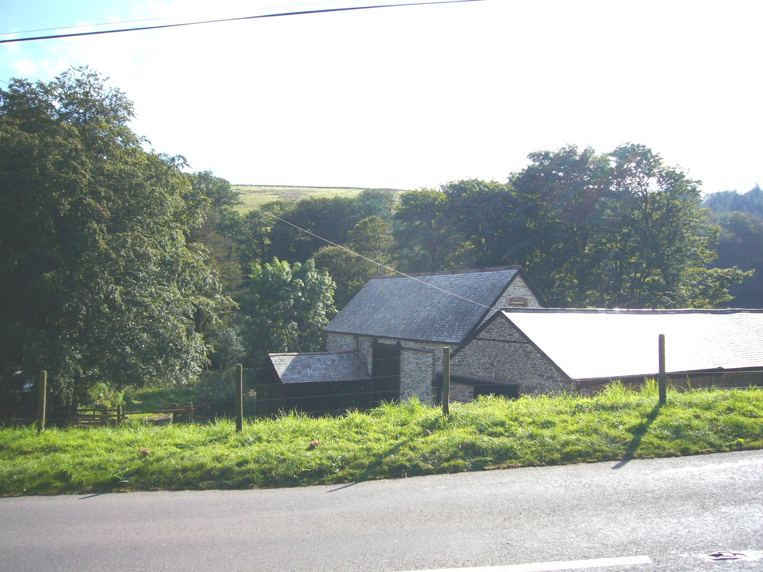
These simple buildings house a restored 19th-century water-powered sawmill now producing wood products for Exmoor National Park and sometimes open to visitors for guided tours.

The creation of the Exmoor estate by the Knight family used a great deal of wood for fencing, gates, hurdles, and building work. Thousands of trees were planted to provide timber as well as shelter and a sawmill was built near Simonsbath House. In the late 1890s the sawmill was rebuilt, with additional machinery for crushing maize for feed and chaff cutting. The estate carpenter had a new workshop on the site. In the early 20th-century the waterwheel was replaced by a turbine and the mill was generating electricity to light some of the nearby houses and the hotel.

After lying unused for many years the sawmill, mill leat and adjoining meadows were bought by the Exmoor National Park Authority in 1996 with the help of a grant from the Heritage Lottery Fund. Between 2001 and 2003 the mill and leat were restored. The leat was damaged in the 1952 flood but was designed to carry water from the River Barle and its tributary the Bale Water to drive the waterwheel at the mill and later the turbine. The mill including the restored saw bench can be driven by the turbine or by a diesel engine when the water levels are too low to fill the leat.

The mill is now used to produced the Park’s footpath signs, gates, stiles, and bridges, from trees felled locally during conservation and enhancement work in the woods

copyright
All rights, including copyright ©, of the content of this document are owned or controlled by the University of London. For further information refer to http://www.englandspastforeveryone.org.uk/Info/Disclaimer

