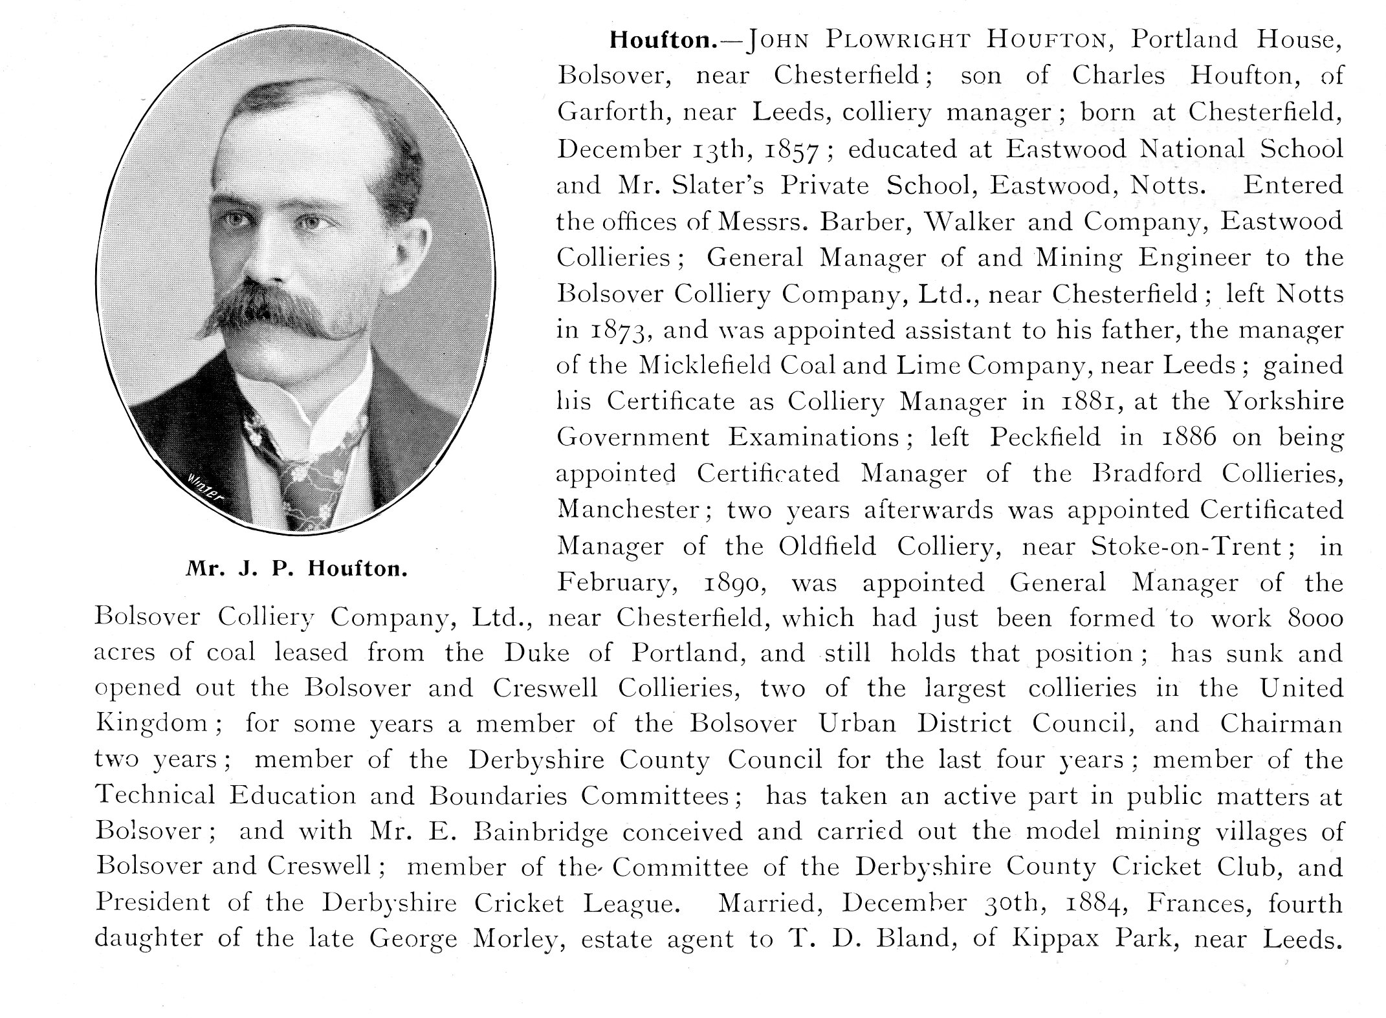
JOHN PLOWRIGHT HOUFTON

This article is from Nottinghamshire and Derbyshire at the Opening of the Twentieth Century: Contemporary Biographies, edited by W.T. Pike, published in 1901. John Plowright Houfton died on the 18 November 1929. Though it is not entirely clear from this biography, or from that of Percy Bond Houfton in the same publication, they were cousins.

At his death in 1929 Sir John Plowright Houfton was described in his Derbyshire Times obituary (edition of 23 November 1929) as ‘a great public man’ with a ‘long and distinguished association with the Bolsover Colliery Company',
On his death, aged 71, Houfton lived at The Park, Mansfield. The Derbyshire Times commented; ‘…his career was one of the romances of the industrial world, and proving what can be done by indomitable perseverance, a great capacity for work, signal ability and a profound knowledge of men.’
Houfton was born in Eyre Street, Chesterfield, where his father was the manager of the Wingerworth Iron Company’s pits. At the age of 14 he entered Messrs. Barber and Walker’s office at Nether Green, Sheffield. His father had moved to work for that company when Houfton was four years old.
Houfton moved with his father three years later to Micklefield, Yorkshire when the latter was appointed manager of the colliery there. Houfton gained experience of sinking and the development of collieries while he was at Micklefield. He obtained his manager’s certificate there.
Aged 28 he was appointed manager of the Bradford Colliery, Manchester. Two years later he took charge of the Lane End Collieries, Fenton, near Stoke-on-Trent.
Houfton’s connection with the Bolsover Colliery Company began in 1890, when he was appointed by Emerson Muschamp Bainbridge, the founder of the Bolsover company, as general manger. Bainbridge died in 1911 and was succeeded as managing director by Houfton.

Houfton followed the example set by Bainbridge’s interest in improving living conditions for his men and their families. This was largely in the hope of fostering better relations between capital and labour. For the company Houfton had overseen the sinking and development of the Bolsover, Creswell and Mansfield Collieries and the Rufford and Clipstone pits.

Associated with these developments were a series of ‘model villages’ of which New Bolsover, was the prototype. During this period Houfton’s cousin, Percy Bond Houfton, came to work at the Bolsover Colliery Company. It was P.B. Houfton who was to design many of the developments put in hand by J.P. Houfton.

In Bolsover J.P. Houfton was active as a school and local board member. He was also a member of the Urban District Council and had represented Bolsover on Derbyshire County Council. He was chairman of the Bolsover Gas Company and of the Bolsover Home Grown Fruit Preserving Company. Perhaps typically, P.B. Houfton designed this establishment.
J.P. Houfton was also a vice-patron of the Chesterfield Royal Hospital.
Houfton retired from the Bolsover Colliery Company in 1919, although he remained a director and consulting engineer to the company. Under him the company became notorious as a supporter of ‘non-political’ unionism, not only in Nottinghamshire, where the movement had more support anyway, but also in Derbyshire. In the early 1920s the company was identified as a backer of both the British Workers’ League and the Midland Counties Industrial Protection Society. In 1925 about half of its men were said to be non-unionists.
In 1908 Houfton left Bolsover to live in Mansfield. Here he was elected a councillor in 1909, becoming Mayor two years later.
On the death of W.E. Harvey, M.P., Houfton contested the North East Derbyshire constituency as a Liberal, but was unsuccessful. In 1922 he contested East Nottingham as a Unionist, following the death of the sitting M.P. He was elected with a majority of 4,973. Apparently, on the eve of the election, Bolsover Colliery Company employees in the district had supported him through the issuing of a manifesto. Despite this he was defeated the following year.

Houfton had been a president of the National Association of Colliery managers (and president of the Midland branch) and President of the Midland Institute of Mining Engineers.

He had been Knighted only in the June before his death, for public and political services.

