NEW CHURCH (Swedenborgian), SNODLAND

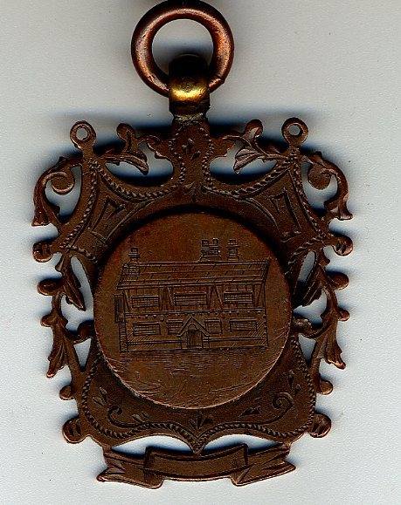

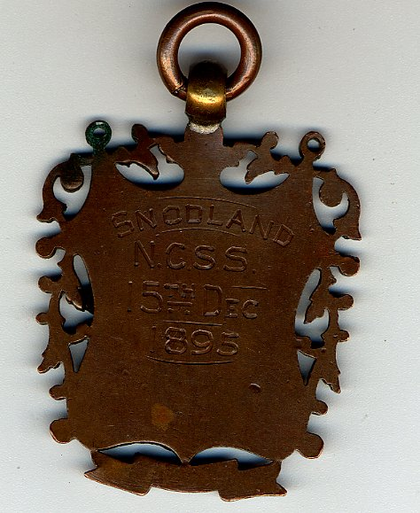

The badge presented at the opening of the Devonshire Rooms, Waghorn Road, Snodland, on 15 December 1895. One function of the rooms was to serve as a Sunday School for the Swedenborgian church of the New Jerusalem and presumably it was given to all Sunday School children at the time. ‘NCSS’ is therefore ‘New Church Sunday School’.

